



**Intellectual Property Management Plan**

**February 28, 2011**

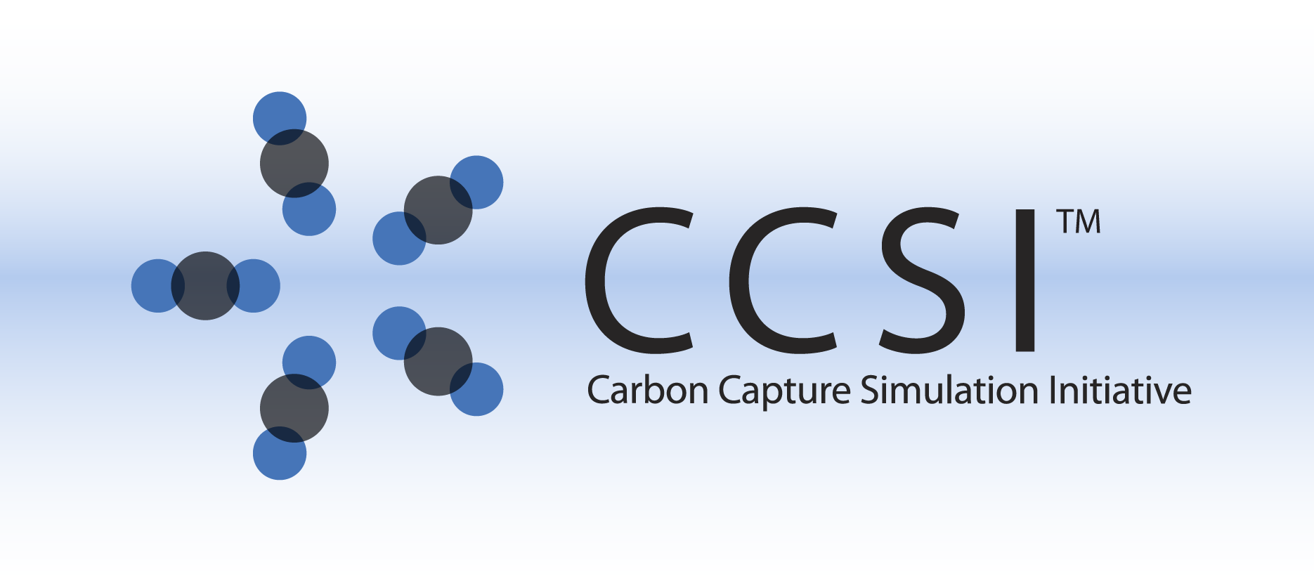

D-RM BUILDER INSTALLATION GUIDE

Version 2.0.0

March 2018

Copyright (c) 2012 - 2018

**Copyright Notice**

D-RM Builder was produced under the DOE Carbon Capture Simulation Initiative (CCSI), and is copyright (c) 2012 - 2018 by the software owners: Oak Ridge Institute for Science and Education (ORISE), Los Alamos National Security, LLC., Lawrence Livermore National Security, LLC., The Regents of the University of California, through Lawrence Berkeley National Laboratory, Battelle Memorial Institute, Pacific Northwest Division through Pacific Northwest National Laboratory, Carnegie Mellon University, West Virginia University, Boston University, the Trustees of Princeton University, The University of Texas at Austin, URS Energy & Construction, Inc., et al.. All rights reserved.

NOTICE. This Software was developed under funding from the U.S. Department of Energy and the U.S. Government consequently retains certain rights. As such, the U.S. Government has been granted for itself and others acting on its behalf a paid-up, nonexclusive, irrevocable, worldwide license in the Software to reproduce, distribute copies to the public, prepare derivative works, and perform publicly and display publicly, and to permit other to do so.

**License Agreement**

D-RM Builder Copyright (c) 2012 - 2018, by the software owners: Oak Ridge Institute for Science and Education (ORISE), Los Alamos National Security, LLC., Lawrence Livermore National Security, LLC., The Regents of the University of California, through Lawrence Berkeley National Laboratory, Battelle Memorial Institute, Pacific Northwest Division through Pacific Northwest National Laboratory, Carnegie Mellon University, West Virginia University, Boston University, the Trustees of Princeton University, The University of Texas at Austin, URS Energy & Construction, Inc., et al. All rights reserved.

Redistribution and use in source and binary forms, with or without modification, are permitted provided that the following conditions are met:

1. Redistributions of source code must retain the above copyright notice, this list of conditions and the following disclaimer.
2. Redistributions in binary form must reproduce the above copyright notice, this list of conditions and the following disclaimer in the documentation and/or other materials provided with the distribution.
3. Neither the name of the Carbon Capture Simulation Initiative, U.S. Dept. of Energy, the National Energy Technology Laboratory, Oak Ridge Institute for Science and Education (ORISE), Los Alamos National Security, LLC., Lawrence Livermore National Security, LLC., the University of California, Lawrence Berkeley National Laboratory, Battelle Memorial Institute, Pacific Northwest National Laboratory, Carnegie Mellon University, West Virginia University, Boston University, the Trustees of Princeton University, the University of Texas at Austin, URS Energy & Construction, Inc., nor the names of its contributors may be used to endorse or promote products derived from this software without specific prior written permission.

THIS SOFTWARE IS PROVIDED BY THE COPYRIGHT HOLDERS AND CONTRIBUTORS "AS IS" AND ANY EXPRESS OR IMPLIED WARRANTIES, INCLUDING, BUT NOT LIMITED TO, THE IMPLIED WARRANTIES OF MERCHANTABILITY AND FITNESS FOR A PARTICULAR PURPOSE ARE DISCLAIMED. IN NO EVENT SHALL THE COPYRIGHT OWNER OR CONTRIBUTORS BE LIABLE FOR ANY DIRECT, INDIRECT, INCIDENTAL, SPECIAL, EXEMPLARY, OR CONSEQUENTIAL DAMAGES (INCLUDING, BUT NOT LIMITED TO, PROCUREMENT OF SUBSTITUTE GOODS OR SERVICES; LOSS OF USE, DATA, OR PROFITS; OR BUSINESS INTERRUPTION) HOWEVER CAUSED AND ON ANY THEORY OF LIABILITY, WHETHER IN CONTRACT, STRICT LIABILITY, OR TORT (INCLUDING NEGLIGENCE OR OTHERWISE) ARISING IN ANY WAY OUT OF THE USE OF THIS SOFTWARE, EVEN IF ADVISED OF THE POSSIBILITY OF SUCH DAMAGE.

You are under no obligation whatsoever to provide any bug fixes, patches, or upgrades to the features, functionality or performance of the source code ("Enhancements") to anyone; however, if you choose to make your Enhancements available either publicly, or directly to Lawrence Berkeley National Laboratory, without imposing a separate written license agreement for such Enhancements, then you hereby grant the following license: a non-exclusive, royalty-free perpetual license to install, use, modify, prepare derivative works, incorporate into other computer software, distribute, and sublicense such enhancements or derivative works thereof, in binary and source code form. This material was produced under the DOE Carbon Capture Simulation Initiative

Table of Contents

1. Introduction 1

2. Prerequisites 1

2.1. Hardwad 1

2.2. Software 1

2.2.1 Required third party software packages 1

3. Basic Installation 1

3.1. Third Party Software Installation 1

3.1.1 SimSinter Installation 1

3.1.2 Aspen Installation 1

3.2. Product Build (For Developers Only) 2

3.3. Product Installation 2

4. Installation Test 2

5. Installation Problems 3

5.1. Known Issues/Fixes 3

5.2. Reporting Installation issues 3

# Introduction

D-RM Builder is a software toolkit for generating dynamic reduced models (D-RMs) from high-fidelity dynamic models or transient experimental data. Currently it supports high-fidelity dynamic models in Aspen Custom Modeler (ACM) form. The program was written in C++ for CPU intensive calculations and Python for Graphic User Interface (GUI) using PySide libraries. Although the code can be compiled on both Windows and Linux platform, it requires another CCSI package named SimSinter, which is also a Windows program. For those users who are not interested in further development, a Microsoft software installer “DRMBuilderSetup.msi” is provided for the current version that can be installed on Windows platform (Windows 7 or higher). To launch ACM simulations from D-RM Builder, the user also needs to install Aspen Tech’s ACM program.

# Prerequisites

## Hardwad

A computer run on Windows operating system

## Software

D-RM Builder is a software package to generate data-driven nonlinear dynamic models from high-fidelity ACM dynamic models or from experimental data of an existing plant. It has been tested on 32 bit and 64 bit windows platforms. The current version is compiled in 32-bit system, which can be installed on both 32 bit and 64 bit Windows operating systems.

### 2.2.1 Required third party software packages

For developers who are interested in future revision and enhancement of the software package, Miscrosoft Visual Studio (version 2012 or higher) and Python 2.7 are needed.

For end users who are not interested in modifying the source code, no computer language packages are needed. The installer will install binary executables and required libraries, along with examples and documents.

Note: For both developers and end users, Aspen Tech’s ACM software package (Version 8.6 or higher) needs to be installed along with another CCSI’s tool named SimSinter, which is used to run ACM dynamic simulations.

# Basic Installation

## Third Party Software Installation

### 3.1.1 SimSinter Installation

Please follow the instructions of SimSinter to install the CCSI package.

### 3.1.2 Aspen Installation

Please follow Aspen Tech’s installation guide to install ACM version 8.6 or higher.

## Product Build (For Developers Only)

Developers need to install Python 2.7 and Microsoft Visual Studio (version 2012) or higher on their Windows computer in order to compile and debug the program. Two Python packages including numpy and matplotlib also need to be installed.

There are two C++ projects in D-RM Builder, namely pyDRMSampling and pyDRMTraining. The two projects are compiled by Visual Studio to create two Python extension DLLs named “pyDRMSampling.pyd” and “pyDRMTraining.pyd” located in the “DLLs” folder. The two modules can be imported to Python code and called by passing a Python tuple as input parameter and returning a Python tuple as results.

To build two DLLs (pyd files), simply open the two corresponding Visual Studio solution files and run “Build Solution” command through the Visual Studio GUI. The DLLs are created in the “DLLs” folder.

The main program is written in Python with PySide for GUI. “main_dymbuiler.py” contains a main function which calls other Python code in “gui” and “framework” directories. Python’s py2exe library is used to create the binary distribution files. To create a distribution, run the following command in DOS prompt at the main source code directory:

Python setup.py py2exe

It will create a folder named “build” and a folder name “dist”. The files in the “dist” folder are the files that need to be installed on end user’s computer. The executable program to launch D-RM Builder is “main_drmbuilder.exe”. It is strongly recommended that those files be wrapped in an installer with user’s manual and examples in the “docs” and “examples” folders. The Microsoft installer file for the current version “DRMBuilderSetup.msi” is provided for this initial open source release.

## Product Installation

For end users, simply run the provided Windows installer “DRMBuilderSetup.msi”. Follow the instructions of the installer to complete the installation process. It is required that the user accept the license agreement displayed in one of the dialog window. The user also has the option to install the program in a user specified directory. The default directory is “C:\Program Files (x86)\CCSI\DRMBuilder”. It also creates a shortcut on user’s desk top and adds the program to Windows’ “Start” menu.

# Installation Test

Simply click the shortcut on user’s desktop or Window’s start menu. When the D-RM Builder is run for the first time, it will create a configuration file “config.txt” in the “C:\ProgramData\CCIS\DRMBuilder” folder. The configuration file contains the full path of the SimSinter’s installation directory. If SimSinter is installed in its default direction at “C:\Program Files (x86)\CCSI\SimSinter”, the “config.txt” will be created automatically. Otherwise, the user needs to browse to SimSinster’s installation directory. If SimSinter is not installed, the user needs to install it first and configure its path next time D-RM Builder is launched. D-RM Builder will exit if SimSinter is not installed. If both SimSinter and D-RM Builder are installed and configured correctly. The main window of D-RM Builder displays as shown in Figure 1. Once configured, D-RM Builder will not ask for the location of SimSinter when it is launched next time.

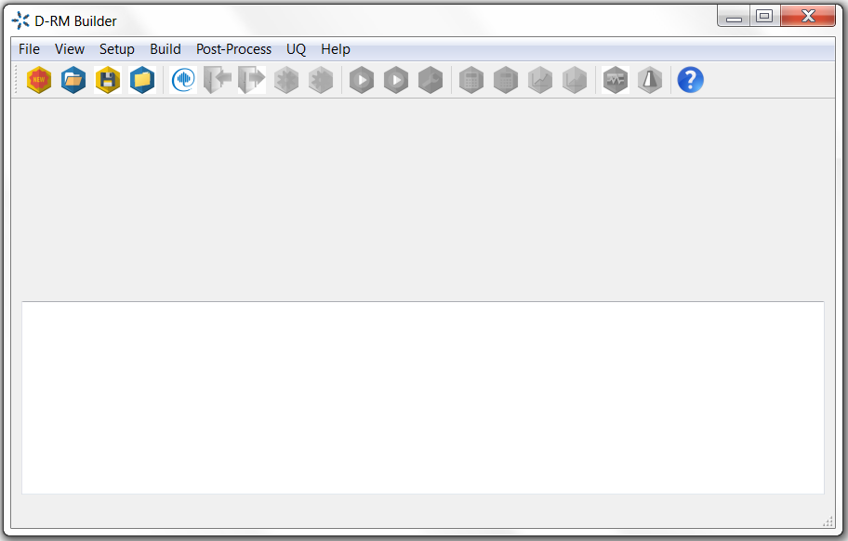

Figure 1. D-RM Builder Main Window

# Installation Problems

## Known Issues/Fixes

N/A

## Reporting Installation issues

Contact [ccsi-support@acceleratecarboncapture.org](mailto:ccsi-support@acceleratecarboncapture.org).

The email of lead development team for this product is

[jinliang.ma@netl.doe.gov](mailto:jinliang.ma@netl.doe.gov),